Install AWS CLI

<https://awscli.amazonaws.com/AWSCLIV2.msi>

verify installation

aws –-version

Install the Elastic Beanstalk CLI

* Install python

<https://www.python.org/downloads/release/python-3127/>  
  
install check the option “Add Python to PATH”

* Install the AWS Elastic Beanstalk CLI  
    
  open cmd and run as admin  
    
  >> pip install awsebcli  
    
  verify installation  
    
  >> eb --version

Configure the AWS CLI

* Create new IAM user  
    
  A screenshot of a computer

  Description automatically generated
* Allow CLI and create access key and secret key
* Login to aws console

>>aws configure

Create BeansTalk manually and test

Note- from 1st of October we need to use aws lunch template.

1. **Create a Launch Template**:
   * Go to the **EC2 Dashboard** in the AWS Management Console.
   * Select **Launch Templates** from the left-hand menu.
   * Click on **Create launch template**.
   * Fill in the necessary details such as the template name, version description, and instance configuration (AMI, instance type, key pair, etc.).
   * Save the template.
2. **Option Settings for Launch Templates**:
   * Ensure you set at least one of the following options in your environment configuration:
     1. DisableIMDSv1 set to true.
     2. RootVolumeType set to gp3.
     3. BlockDeviceMappings containing gp3.

Now BeansTalk creation will be successful.  
  
Deploy application to beanstalk using cli

>> eb init  
  
Note- you can create new or can choose the existing one

If creating new run the below cmd

>> eb create

Deploy the application to it

>> eb deploy  
  
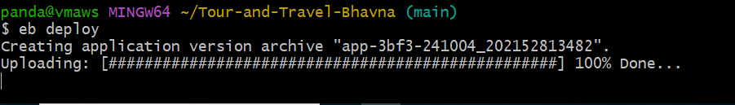

You will see deployment progress  
  
  
  
  
ERROR--------

2024-10-04 20:22:40 INFO Deploying new version to instance(s).

2024-10-04 20:24:03 ERROR Instance deployment failed to generate a 'Procfile' for Node.js. Provide one of these files: 'package.json', 'server.js', or 'app.js'. The deployment failed.

2024-10-04 20:24:03 ERROR Instance deployment failed. For details, see 'eb-engine.log'.

2024-10-04 20:24:03 ERROR [Instance: i-0b8d0001335112b23] Command failed on instance. Return code: 1 Output: Engine execution has encountered an error..

2024-10-04 20:24:04 INFO Command execution completed on all instances. Summary: [Successful: 0, Failed: 1].

2024-10-04 20:24:04 ERROR Unsuccessful command execution on instance id(s) 'i-0b8d0001335112b23'. Aborting the operation.

2024-10-04 20:24:04 ERROR Failed to deploy application.

ERROR: ServiceError - Failed to deploy application.

This issue was dur to environment type, I was deploying php application but the platform was node js.  
  
make sure you create correct platform.

To switch environments

>> eb use environment-name